ANIH BERHAD & MTD GROUP CSR PROGRAM : 'BERKONGSI BARAKAH'
Appendix 5
IFTAR FOOD PACK GIVEAWAY TO ROAD USERS ON 11 JUNE 2018, AT RSA GENTING SEMPAH (EAST/WEST BOUND), BENTONG PAHANG.

ANALYSIS OF EFFECTIVENESS

Findings

At the end of the program, 15 evaluation forms have been given to the selected highway patrol team members, food stall workers as well as road users. This is to measure the success of the program.

The evaluation form covers 5 major scopes:
- Program
- Event handout
- Event Delivery
- Event Management
- Event facilities

The evaluation form will be a benchmark for the CSR Panel to evaluate effectiveness of the program and to serve as a guide for CSR Members in implementing further CSR programs.
Program

In Program section, 66.7% of respondents gave rating excellent for the event. The section covers “Overall satisfaction”, “The relevance to the event for current work”, and “The benefits of meeting colleagues/exchanging information”.
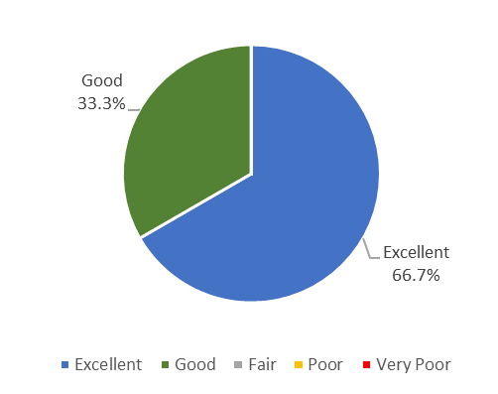

b) Event handout

Total 10 of 15 respondent equivalent 66.7% gave rating excellent for Material section. During the program, the organiser has distributed a Time Table Advisory (TTA) to the road users. In fact, road users able to plan their journey during the Hari Raya Aidilfitri festive. The Material covers “The usefulness of the background material” and “The usefulness of the event handouts”.

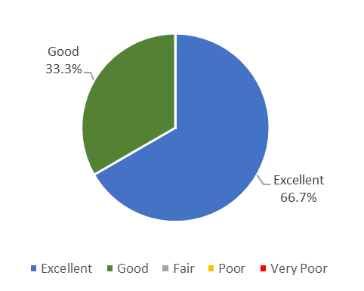
c) Event Delivery

In Event Delivery section, the program received excellent rating with 71.1% and good with 28.9% with the opportunities to interact with other participants during the program. The section covers “Overall the quality of discussion or/and dialogue”, “The opportunities for participants to interact (have question answered, share concerns and experiences, etc) during the event”, and “Emcee and speakers presentation”.

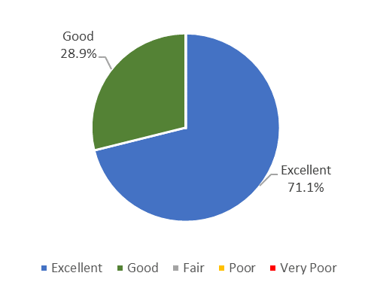

d) Event Administration

In the section, 75.6% given rating excellent and 24.4% for good ratings. The Event Administration covers Overall satisfaction with the event coordination, Did received event information in sufficient time before, and The usefulness of information received.

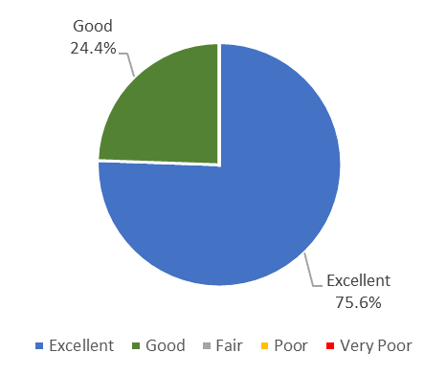
e) Event Facilities

On Event Facilities, 63.3% respondent gave rating good. This covers for “The quality of the facilities (room, furniture, communication aids, photocopying, etc) provide at the event” and “The quality of the administration (staff responsive, etc) at the event.”

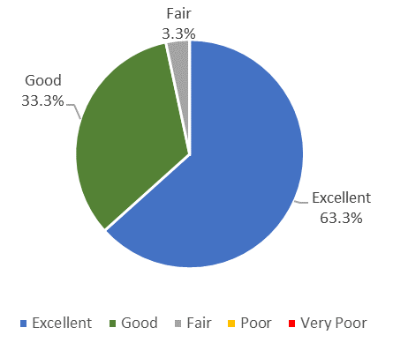

Conclusion

Overall, the program had successfully managed based on the finding of the respondents' evaluation, which is 69.2% for excellent rating.

